Setting Up a Training Tenant & Subscription for 14 Students
A step-by-step guide using one centrally managed Microsoft Entra tenant and one Azure subscription. Updated for the current Azure portal / Microsoft Entra admin center UI (August 2026), with screenshot placeholders for each key step.
Yes. Below is the cleanest way to set this up from scratch for 14 students using one centrally managed Microsoft Entra tenant and one Azure subscription.
The key point first: the tenant is for identities; the Azure subscription is for billing/resources. So you will create the tenant, create 14 student users inside it, then make sure the training subscription is associated with that tenant, create one resource group per student, and assign each student Contributor only to their own resource group.
UI UPDATE (2026): Microsoft Entra ID identity management now lives primarily in its own admin center at entra.microsoft.com, separate from the classic Azure portal (portal.azure.com). Both work side by side — you can still reach every Entra screen by searching "Microsoft Entra ID" from the Azure portal's top search bar — but Microsoft's own documentation now points to entra.microsoft.com first. Screens, menu names, and the navigation paths below are otherwise unchanged.
Microsoft's current guidance says a new workforce tenant is created from Microsoft Entra ID → Overview → Manage tenants → Create, choosing Microsoft Entra ID rather than B2C.

Step 1 — Confirm you have a paid Azure subscription
Before creating the tenant, sign in to the Azure portal with the account that owns or administers the subscription you plan to use for training.
Check:
Azure Portal → Subscriptions → Select your subscription
Make sure the subscription status is Active.
📷 SCREENSHOT PLACEHOLDER
Step 1 — Subscriptions list showing status = Active
This matters because Microsoft currently states that creating an additional workforce tenant is generally available to paid customers with the necessary billing/ARM permissions; trial/free tenants may not be able to create additional workforce tenants.

Step 2 — Create the Microsoft Entra tenant
Go to:
https://portal.azure.com — or go directly to https://entra.microsoft.com, the dedicated Microsoft Entra admin center.
Then:
Microsoft Entra ID → Overview → Manage tenants → Create
UI UPDATE (2026): As of mid-2026, the Create wizard opens on a new screen — "Choose a configuration for your tenant" — with Governed Workforce pre-selected as the recommended option, alongside Workforce (legacy) and External. For a training lab, pick Workforce (legacy). Governed Workforce adds extra prerequisites you don't need here: it requires Tenant Contributor permissions on a Microsoft Customer Agreement (MCA) subscription (Enterprise Agreement subscriptions aren't supported), and a default governance policy template configured in your home tenant, or the governance relationship simply won't be established. None of that is needed for a self-contained student lab tenant.
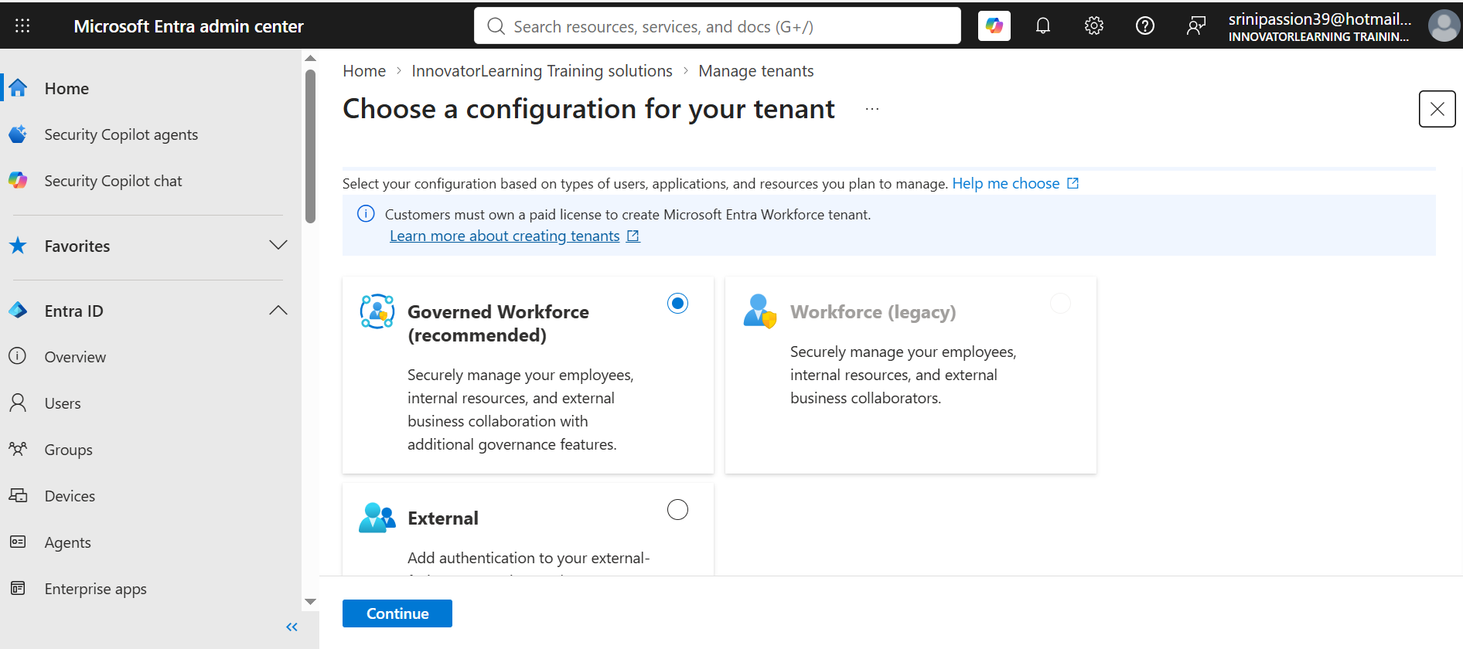
Actual screen: "Choose a configuration for your tenant" — select Workforce (legacy) for a training lab, then Continue.
Choose:
Workforce (legacy) → Continue
Do not choose B2C/External for this training setup — you need a normal workforce tenant for internal student accounts.
On the Basics tab, enter:
Tenant name:
Cloud Data GenAI Training
Domain name:
cloudgenaitraining26
Country/Region:
India (or your current selection)
UI UPDATE (2026): The Basics tab now also includes a required Subscription field directly on this screen — this wasn't there before. Select your training subscription here (this is the subscription that will host the Microsoft Entra ID Free billing asset for the tenant). Selecting it now effectively pre-links the tenant and subscription, which is what Step 10 later confirms — so pay attention here and pick the correct training subscription, not a personal/other one.
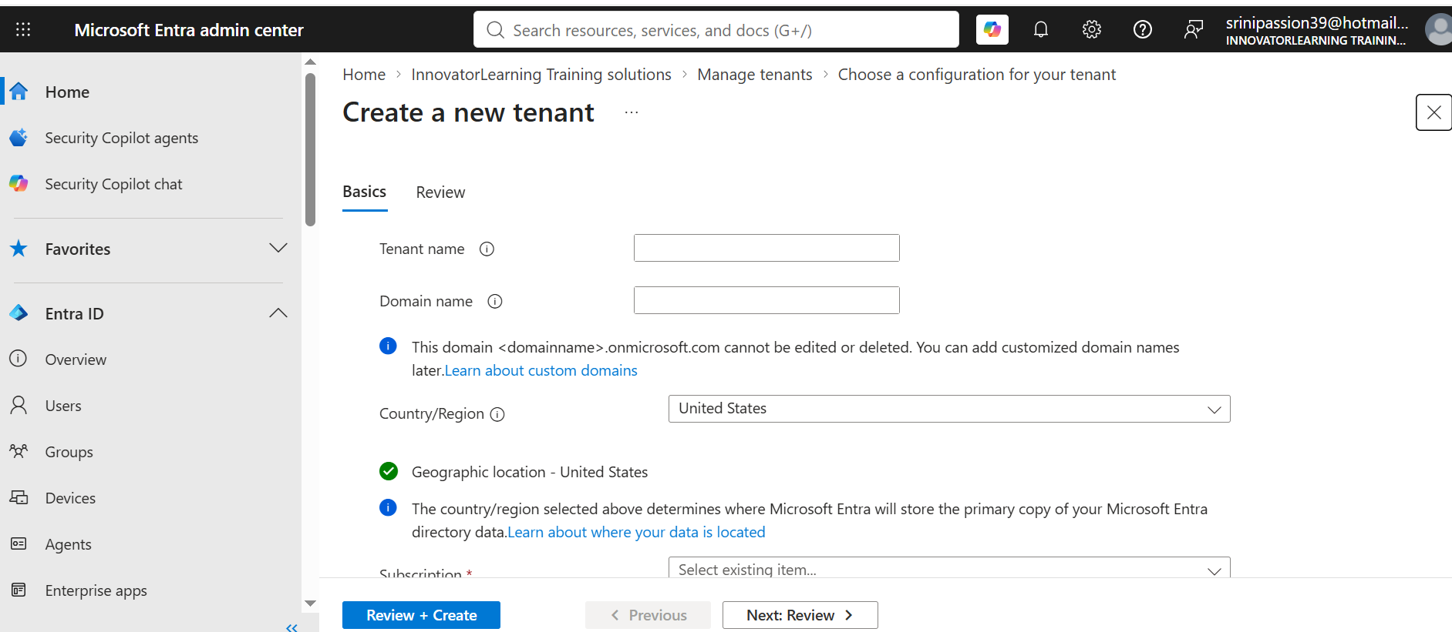
Actual screen: "Create a new tenant" → Basics tab, showing Tenant name, Domain name, Country/Region, and the new required Subscription field.
Your resulting tenant domain will look like:
cloudgenaitraining26.onmicrosoft.com
The initial onmicrosoft.com domain is permanent, so choose the name carefully.
Then:
Review + Create → Create

Step 3 — Switch into the new tenant
After creation:
Microsoft Entra ID → Manage tenants
Select your new tenant. Then choose:
Switch
You should now see something similar to:
Tenant name: Cloud Data GenAI Training
Primary domain: cloudgenaitraining26.onmicrosoft.com
Tenant ID: xxxxxxxx-xxxx-xxxx-xxxx-xxxxxxxxxxxx
Save the Tenant Name, Tenant ID, and Primary Domain. You will need these later.
📷 SCREENSHOT PLACEHOLDER
Step 3 — Tenant Overview page after switching, showing Tenant name / Primary domain / Tenant ID
UI UPDATE (2026): Common error at this step: "Selected user account does not exist in tenant '<name>' and cannot access the application '...'. The account needs to be added as an external user in the tenant first." This means you're signed in with an account that was never added to this specific tenant — usually because the tenant was created under a different Microsoft account than the one you're currently signed in as. Fix it by either (a) signing out and back in with the account that actually created the tenant (it's the Global Administrator by default), or (b) having an existing admin in that tenant invite your account as a guest via Entra ID → Users → New user → Invite external user.

Step 4 — Understand what you currently have
At this point, the architecture looks like:
Your Microsoft Account
↓
Microsoft Entra Tenant — cloudgenaitraining26.onmicrosoft.com
- No students yet
- No training resources yet
The next step is to create the 14 users.

Step 5 — Create Student 01 manually first
Before doing a bulk import, I recommend creating one account manually and testing it.
Go to:
Microsoft Entra ID → Users → All users → New user → Create new user
Enter:
User principal name: student01@cloudgenaitraining26.onmicrosoft.com
Display name: Student 01
Password: Auto-generate password
or create a temporary password that meets the tenant's current password requirements.
Enable: Require password change at next sign-in
if available/appropriate for your lab.
📷 SCREENSHOT PLACEHOLDER
Step 5 — "Create new user" form with UPN, display name, and password settings
Then click:
Review + Create

Step 6 — Test Student 01 login
Open an Incognito/InPrivate browser.
Go to: https://portal.azure.com
Login as: student01@cloudgenaitraining26.onmicrosoft.com
Use the temporary password.
The student may be asked to:
- Change password
- Register MFA
- Accept security information
depending on your tenant/security policies.
At this stage, the student can authenticate, but will probably not yet have access to Azure resources. That is expected.

Step 7 — Create all 14 students using Bulk Create
For 14 users, bulk creation is much faster than manually creating all of them.
Microsoft Entra supports bulk creation through:
Entra ID → Users → Bulk create
and Microsoft currently requires at least the User Administrator role for bulk user creation.
Go to:
Microsoft Entra ID → Users → Bulk operations → Bulk create
Depending on the portal view, it may simply show:
Users → Bulk create
Download the CSV template.
UI UPDATE (2026): The downloaded CSV template now starts with a required first row containing the template version (for example version:v1.0). Keep that row exactly as downloaded — don't delete or edit it — and add your student rows starting from row 4. Removing or altering it will cause the upload to fail validation.
Microsoft says the first four fields are required:
- Name
- User principal name
- Initial password
- Block sign in
📷 SCREENSHOT PLACEHOLDER
Step 7 — "Bulk create" page with the Download template button and Upload panel

Step 8 — Prepare the 14-student CSV
Your CSV could conceptually look like this (columns: Name, User principal name, Initial password, Block sign in):
Student 01,student01@cloudgenaitraining26.onmicrosoft.com,Temp@Azure2601,No
Student 02,student02@cloudgenaitraining26.onmicrosoft.com,Temp@Azure2602,No
Student 03,student03@cloudgenaitraining26.onmicrosoft.com,Temp@Azure2603,No
Student 04,student04@cloudgenaitraining26.onmicrosoft.com,Temp@Azure2604,No
Student 05,student05@cloudgenaitraining26.onmicrosoft.com,Temp@Azure2605,No
Student 06,student06@cloudgenaitraining26.onmicrosoft.com,Temp@Azure2606,No
Student 07,student07@cloudgenaitraining26.onmicrosoft.com,Temp@Azure2607,No
Student 08,student08@cloudgenaitraining26.onmicrosoft.com,Temp@Azure2608,No
Student 09,student09@cloudgenaitraining26.onmicrosoft.com,Temp@Azure2609,No
Student 10,student10@cloudgenaitraining26.onmicrosoft.com,Temp@Azure2610,No
Student 11,student11@cloudgenaitraining26.onmicrosoft.com,Temp@Azure2611,No
Student 12,student12@cloudgenaitraining26.onmicrosoft.com,Temp@Azure2612,No
Student 13,student13@cloudgenaitraining26.onmicrosoft.com,Temp@Azure2613,No
Student 14,student14@cloudgenaitraining26.onmicrosoft.com,Temp@Azure2614,No
But important: use Microsoft's downloaded CSV template and preserve the exact column headers (and the version row noted above). Microsoft explicitly warns that the bulk file must match the provided template.
Also, I would not use the example passwords above in a real class. Generate strong unique temporary passwords and distribute them privately.

Step 9 — Upload the CSV
Go back to:
Microsoft Entra ID → Users → Bulk create
Upload the CSV. Wait for: File uploaded successfully
Then: Submit
📷 SCREENSHOT PLACEHOLDER
Step 9 — Bulk create job status showing "File uploaded successfully" / job progress
After completion:
Microsoft Entra ID → Users → All users
Verify: Student 01 … Student 14
Microsoft notes that bulk-created internal users do not automatically receive invitation emails, so you need to share credentials yourself.

Step 10 — Make the Azure subscription available in this tenant
This is the part that often causes confusion. You need:
Training Tenant → Azure Subscription
If the subscription is already associated with this new tenant, great.
Go to:
Azure Portal → Subscriptions
Check whether your subscription is visible.
If the subscription is still associated with another directory, you may need to change the subscription's directory/tenant. Be careful here because changing directories can affect RBAC assignments and service identities.
For your training environment, confirm this before creating resources.
📷 SCREENSHOT PLACEHOLDER
Step 10 — Subscriptions blade confirming the training subscription's Directory = your new tenant
The end result should be:
cloudgenaitraining26.onmicrosoft.com → Training Subscription

Step 11 — Create 14 Resource Groups
Now create one Resource Group per student. Use:
rg-cdg-s01
rg-cdg-s02
rg-cdg-s03
…
rg-cdg-s14
I recommend not putting day01 in the RG name if you plan to use the same student RG across the full training. For example, inside rg-cdg-s01 later: Day 1 resources, Day 2 resources, Storage, VMs, App Service, etc.
This is easier to manage than creating 14 new RGs every single day.

Step 12 — Create Resource Groups from the Portal
Go to:
Azure Portal → Resource Groups → Create
Select:
Subscription: Your Training Subscription
Resource Group: rg-cdg-s01
Region: Central India
Then: Review + Create → Create
Repeat through rg-cdg-s14.
📷 SCREENSHOT PLACEHOLDER
Step 12 — "Create a resource group" blade with subscription, name, and region filled in

Step 13 — Faster method: create all 14 with Azure CLI
You can use Cloud Shell. Example:
for i in $(seq -w 1 14)
do
az group create --name rg-cdg-s$i --location centralindia
done
That creates rg-cdg-s01, rg-cdg-s02, … rg-cdg-s14. This saves significant time.

Step 14 — Assign Student 01 to Resource Group 01
Open:
Resource Groups → rg-cdg-s01 → Access Control (IAM)
Then:
Add → Add role assignment
Select role:
Contributor
Then:
Members → User, group, or service principal → Select members
Search: student01
Select: student01@cloudgenaitraining26.onmicrosoft.com
Then: Review + assign
📷 SCREENSHOT PLACEHOLDER
Step 14 — Access control (IAM) → Add role assignment blade, with Contributor role and student01 selected as member
Microsoft's current RBAC guidance uses exactly this flow: select the target scope, open Access control (IAM), then Add → Add role assignment.

Step 15 — Repeat for the 14 students
Use this mapping:
Student | Account | Resource Group
01 | student01@tenant | rg-cdg-s01
02 | student02@tenant | rg-cdg-s02
03 | student03@tenant | rg-cdg-s03
04 | student04@tenant | rg-cdg-s04
05 | student05@tenant | rg-cdg-s05
06 | student06@tenant | rg-cdg-s06
07 | student07@tenant | rg-cdg-s07
08 | student08@tenant | rg-cdg-s08
09 | student09@tenant | rg-cdg-s09
10 | student10@tenant | rg-cdg-s10
11 | student11@tenant | rg-cdg-s11
12 | student12@tenant | rg-cdg-s12
13 | student13@tenant | rg-cdg-s13
14 | student14@tenant | rg-cdg-s14
Each student gets Contributor at Resource Group Scope — not Subscription Scope.

Step 16 — Why Contributor and not Owner?
Use Contributor because students need to:
- Create resources
- Update resources
- Delete resources
- Configure resources
But they generally should not be allowed to give RBAC access to other users.
So: Student → Contributor → Own Resource Group
is safer than: Student → Owner → Subscription

Step 17 — Test with Student 01
Open Incognito. Sign in: student01@cloudgenaitraining26.onmicrosoft.com
Then go to: Resource Groups
Student 01 should see/access: rg-cdg-s01
Now test creating a Storage Account or a simple tag/resource.
Student 01 should not be able to administer rg-cdg-s02.
📷 SCREENSHOT PLACEHOLDER
Step 17 — Student 01's Resource Groups view, showing only rg-cdg-s01

Step 18 — Final architecture
You should end up with:
Microsoft Entra Tenant — cloudgenaitraining26.onmicrosoft.com
- Trainer / Global Admin
- Student01
- Student02
- Student03
- … through Student14
↓
Azure Training Subscription
- rg-cdg-s01 → Contributor → Student01
- rg-cdg-s02 → Contributor → Student02
- rg-cdg-s03 → Contributor → Student03
- rg-cdg-s04 → Contributor → Student04
- rg-cdg-s05 → Contributor → Student05
- rg-cdg-s06 → Contributor → Student06
- rg-cdg-s07 → Contributor → Student07
- rg-cdg-s08 → Contributor → Student08
- rg-cdg-s09 → Contributor → Student09
- rg-cdg-s10 → Contributor → Student10
- rg-cdg-s11 → Contributor → Student11
- rg-cdg-s12 → Contributor → Student12
- rg-cdg-s13 → Contributor → Student13
- rg-cdg-s14 → Contributor → Student14

Step 19 — What students receive
Send each student only:
Azure Portal: https://portal.azure.com
Username: student01@cloudgenaitraining26.onmicrosoft.com
Temporary Password: ********
Resource Group: rg-cdg-s01
Instructions:
- Login
- Change password if prompted
- Complete MFA if prompted
- Use only your allocated Resource Group
- Do not create another subscription
- Do not enter debit/credit card details
- Do not modify IAM
- Do not create expensive resources without trainer approval

Step 20 — Cost controls to configure before giving access
Because all 14 students consume the same paid subscription, do this before class.
Go to:
Cost Management + Billing → Cost Management → Budgets
Create a budget. For example: Monthly Training Budget
Set alerts at something like: 50%, 75%, 90%, 100%
📷 SCREENSHOT PLACEHOLDER
Step 20 — Budgets blade with a new monthly budget and alert thresholds configured
Also tell students to avoid arbitrary SKUs. For Day 1, restrict them to the tier you specify.
Later, particularly for VM, Databricks, AKS, Azure SQL, and AI services, you should be even more careful because 14 simultaneous environments can consume substantial credit.

Step 21 — Strong recommendation for your 45-day course
For basic Azure labs, give every student their own resources: Storage, VM, VNet, App Service, etc.
But later for expensive services such as Azure Databricks, Azure AI Foundry, Azure AI Search, New Relic integrations, and Synapse, I would not automatically create 14 independent full environments.
Instead consider:
Training Subscription
- 14 student Resource Groups → low-cost individual labs
- Shared Trainer Resource Group → Shared Databricks Workspace, Shared ADLS, Shared datasets, Shared AI Search, Shared AI services
and give students appropriate workspace-level/access permissions. That can reduce cost dramatically.

The first thing you should do now
Don't create all 14 users immediately. First do this sequence:
- Create Tenant
- Create Student01
- Confirm subscription is visible in that tenant
- Create rg-cdg-s01
- Give Student01 Contributor
- Login as Student01
- Create one small resource
Once that succeeds end-to-end, bulk-create Students 02–14.
This avoids discovering a tenant/subscription/RBAC problem after you've already configured all 14 accounts.
Send screenshots as you perform these steps and drop them into the placeholders above — that keeps this guide as an accurate, visual record of your specific tenant/subscription setup.

